Lab 6

Q1. Create a class with a private field and a private method. Create an inner class with a method that modifies the outer-class field and calls the outer-class method. In a second outer-class method, create an object of the inner class and call its method, then show the effect on the outer-class object.

class OuterClass {

    private int outerField = 10;

    private void outerMethod() {

        System.out.println("Outer class method called.");

    }

    class InnerClass {

        void modifyOuterClass() {

            outerField = 20;

            outerMethod();

        }

    }

    void createInnerAndModify() {

        InnerClass inner = new InnerClass();

        inner.modifyOuterClass();

    }

    void display() {

        System.out.println("Outer field value: " + outerField);

    }

}

public class Main {

    public static void main(String[] args) {

        OuterClass outer = new OuterClass();

        System.out.println("Before modification:");

        outer.display();

        outer.createInnerAndModify();

        System.out.println("After modification:");

        outer.display();

    }

}

**Output :**

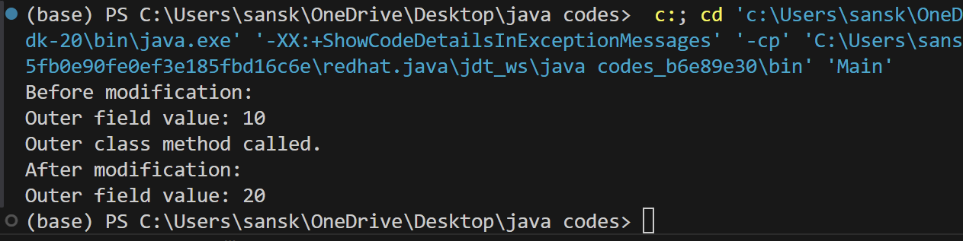

Q2. Determine whether an outer class has access to the private elements of its inner class.

class OuterClass2 {

    public class InnerClass2 {

        private int innerField = 30;

        private void innerMethod() {

            System.out.println("Inner class method called.");

        }

    }

    void accessInnerClass() {

        InnerClass2 inner = new InnerClass2();

        System.out.println("Inner field value: " + inner.innerField);

        inner.innerMethod();

        System.out.println("Cannot access inner class's private field or method directly.");

    }

}

public class Main2 {

    public static void main(String[] args) {

        OuterClass2 outer2 = new OuterClass2();

        outer2.accessInnerClass();

    }

}

**Output :**

